eDNA-TaxAI Project
What Changed Since the Part 4 POC Report
A plain-language and technical walkthrough of Parts 5 through 14:
open-set decisions, model comparisons, three-kingdom validation,
real ocean-sequencing data, per-kingdom fine-tuning, and the
end-to-end architecture evaluation.
Prepared: 29 September 2026

Contents
1. The Simple Version — What This Project Does and What Changed
2. Where We Left Off: The Part 4 Baseline
3. The Production Pipeline — How a Read Becomes an Answer
4. Part 5 — Never Stay Silent: Best-Guess Reporting
5. Parts 6–7 — Testing Other AI Models
6. Part 8 — Does the Method Work Beyond Fish?
7. Parts 9–10 — Real Ocean Data, Two More Kingdoms
8. Part 11 — Teaching the Model Each Kingdom's DNA (First Attempt)
9. Part 12 — Finding and Fixing the Bacteria Bug
10. Part 13 — Does Fine-Tuning Actually Help the Full Pipeline?
11. Part 14 — Finishing the Job for Fish and Eukaryota
12. How the Training Actually Works, Step by Step
13. Complete Results Summary
14. What Is Still Open

1. The Simple Version — What This Project Does and What Changed
Imagine you scoop up a cup of seawater. Floating in that water are tiny, invisible pieces of DNA that fell off fish, bacteria, and plankton as they swam around. This project reads one of those tiny DNA pieces — only about 120 letters long, like a single short text message — and tries to figure out which animal or microbe it fell off, just by comparing it to a giant library of already-known DNA.
The system does this in four steps, like a detective narrowing down a suspect list:
- Step 1 — quick shortlist: first, a fast keyword-style search pulls 30 “maybe” matches out of millions of known DNA sequences;
- Step 2 — smart shortlist: then an AI model, trained to “read” DNA the way it reads sentences, picks the 10 most useful and different candidates from that shortlist;
- Step 3 — double-check: then the system does a real, letter-by-letter comparison (not just an AI guess) to see exactly how similar the read really is to each candidate;
- Step 4 — verdict: finally, based on how similar the best match is, it either confidently names the species, offers a “best guess,” or honestly says “I don't know.”
The last big report you saw, “Part 4,” covered the first big win: adding that letter-by-letter double-check (Step 3) fixed a problem where the AI kept confusing unrelated fish because a couple of reference sequences acted like magnets. That got 9.5% of test reads confidently and correctly matched to real tuna species.
Everything in this report happened after that. In plain terms, here is what changed:
- 1. Smarter honesty. Instead of just saying “I don't know” for anything less than a perfect match, the system now gives a graded answer — confident, best guess, weak guess, or unknown — and looks up the real species name automatically.
- 2. Model shopping. Three other free AI “DNA readers” were tried as replacements for the one already in use. All three were worse — sometimes dramatically worse — so the original model was kept.
- 3. Beyond fish. The whole method was tested on two more groups of life — bacteria and plankton — not just fish, using realistic (simulated) test data. It worked well on all three.
- 4. Real ocean tests. Real seawater DNA samples from an international ocean survey (Tara Oceans) were run through the system for bacteria and plankton, for the first time. Bacteria matched well (66.9% confidently identified); plankton matched less often (4.8%) because its comparison library was much smaller.
- 5. Custom training, take one. The AI model was specially retrained on each group's own DNA, like giving it a crash course in fish, then a separate crash course in bacteria, then plankton. The first attempt had a hidden bug that made the bacteria version worse instead of better.
- 6. The fix. The bug was found (three separate causes, actually) and fixed. The retrained bacteria model went from getting worse to being the single biggest improvement in the whole project.
- 7. The big reveal. Then came the big question: does a better AI model actually produce more correct final answers, or does it get bottlenecked somewhere upstream? The answer, tested rigorously: mostly bottlenecked. Step 1's keyword search already finds almost every correct answer, so a better Step 2 model barely changes the final result — even when, in isolation, that model got dramatically better.
- 8. Finishing the job. Finally, the same retraining and testing that fixed bacteria was repeated for fish and plankton. Both came out even better than expected — fish's improvement nearly doubled versus the first attempt.
Bottom line for a 10-year-old: we taught the AI to know more about DNA (and it got MUCH smarter at that), but the final answers barely changed — because the first, simpler search step was already doing most of the work. The honest, useful finding is knowing THAT, not just making the AI “smarter” for its own sake.

2. Where We Left Off: The Part 4 Baseline
Before diving into what's new, here is the exact state the project was in at the end of Part 4, so the rest of this report has a fixed reference point.
Part 4 solved a problem discovered in Part 3: when the AI model alone was used to find the closest DNA match, a handful of reference sequences acted like “magnets,” pulling in unrelated reads. The fix was to stop trusting the AI's similarity score directly, and instead take its top 10 suggestions and run a real, independent DNA alignment (Smith-Waterman — the same class of algorithm used to compare genomes for decades) to measure the actual percentage of matching letters.
Metric | Part 3 (AI similarity only) | Part 4 (AI + real DNA alignment)
Reads confidently assigned | 211 / 5,000 (4.2%) | 474 / 5,000 (9.5%)
Evidence per match | Similarity score only | Real alignment: median 98.4% identity
Distinct references matched | 13 | 27
Top-2 references' share of matches | 89% | 57%
Species check | Not verified | 93.9% independently confirmed as tuna (NCBI)

That 9.5%-assigned, 93.9%-verified-as-tuna result was the trustworthy foundation everything in this report builds on. It also established the four production building blocks that stayed unchanged for the rest of the project: BM25 lexical search, MMR diversification, the nucleotide alignment reranker, and a calibrated 95%-identity confidence bar.

3. The Production Pipeline — How a Read Becomes an Answer
Every experiment described in this report runs the same four-step production pipeline on the back end. Understanding this diagram makes every later results table easy to read, because every table is really asking: “what happens to the final answer if we change one box in this picture?”
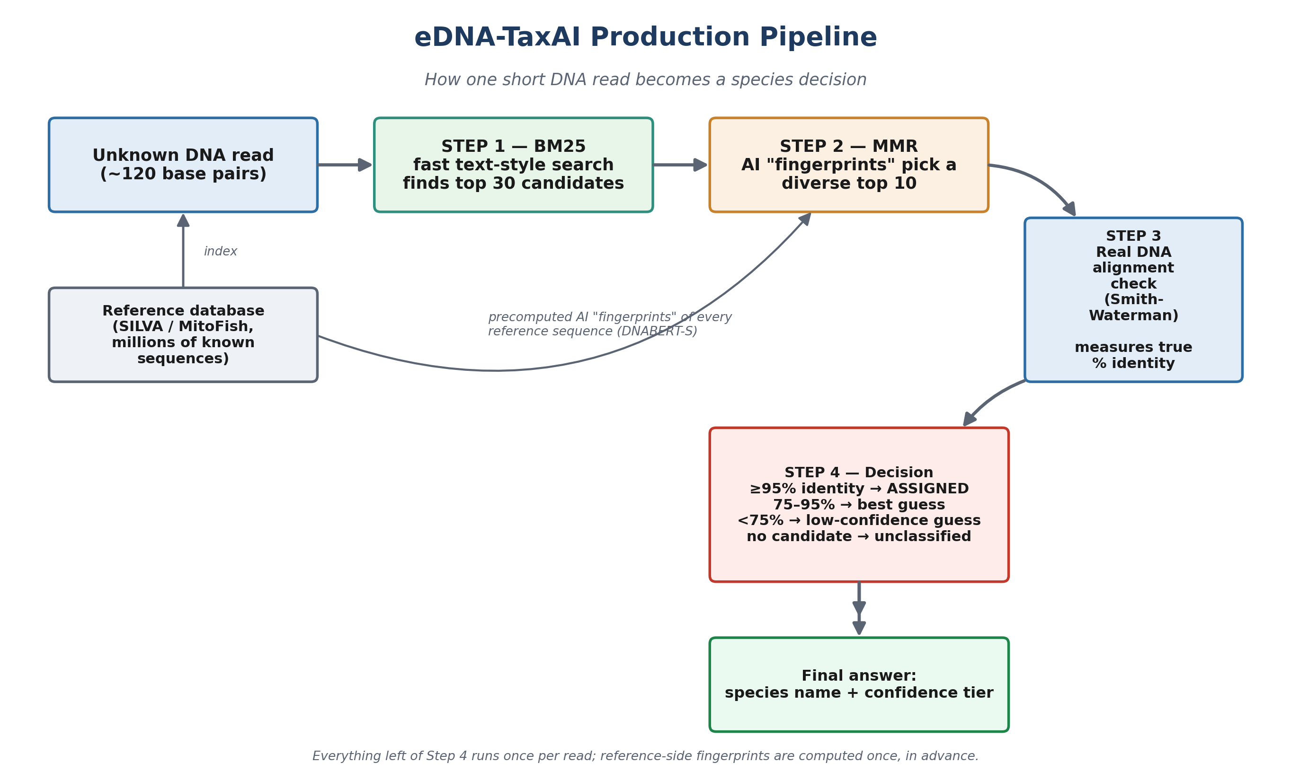
Figure 1. The four-step production pipeline. Reference-side AI fingerprints are computed once in advance; only the read itself flows through Steps 1–4 at query time.

What each step actually does
Step 1 — BM25 (lexical search).
Treats DNA like text and finds references that share unusually specific short sequences (“k-mers”) with the read — similar in spirit to how a search engine finds documents sharing rare words with your search query. Fast, and it does not need any AI model at all. Returns the top 30 candidates.
Step 2 — MMR (Maximal Marginal Relevance).
Uses DNABERT-S, an AI model that converts each DNA sequence into a list of 768 numbers (an “embedding,” or fingerprint) capturing what species it resembles. MMR uses these fingerprints to whittle the 30 BM25 candidates down to a diverse top 10, avoiding picking 10 near-identical sequences when one would do.
Step 3 — Nucleotide reranker (Smith-Waterman alignment).
The step Part 4 added. Ignores AI scores entirely and does a real, direct DNA letter-by-letter alignment between the read and each of the 10 candidates, producing a genuine percent-identity number — the same kind of number a biologist would compute by hand.
Step 4 — Tiered confidence decision.
Identity to best match | Decision | Meaning
≥ 95% | assigned | Confident, trustworthy species call
75–95% | best guess | A real, fairly close lead — worth reporting, not confirmed
< 75% | best guess (low confidence) | Nearest thing found, but weak; flagged as unreliable
No candidate at all | unclassified | The read shares nothing with any reference

The 95% bar is not arbitrary — it was calibrated in Part 4 using held-out data, meaning it was chosen by testing which threshold actually separates correct from incorrect matches, not picked by eye.

4. Part 5 — Never Stay Silent: Best-Guess Reporting
Simple version: before this change, the system either said “yes, this is species X” or stayed completely silent — even though, behind the scenes, it always had a nearest match and a similarity number. A read that was 93% similar to a known fish (a genuinely close lead) was treated exactly the same as a read that was 52% similar to anything (essentially a random match). That throws away real information.
The fix introduced three tiers instead of two (see the table in Section 3), so every read now reports its actual nearest match and identity score, labelled honestly by how much that match should be trusted. A second addition, species_lookup.py, automatically fetches real species names from NCBI's public database instead of showing raw accession codes like “AY920478.”

Real-read check
Running the first 15 reads of the real fish dataset through the updated pipeline:
Tier | Count (of 15) | Identity range | What was found
assigned | 5 | 97.5–100% | All tuna or footballfish — ecologically sensible
best_guess | 1 | 93.5% | A real, fairly close lead
best_guess_low_confidence | 9 | 52–71% | A scattered mix of unrelated deep-sea species

The nine low-confidence reads matching a scattered, unrelated mix of species is exactly the signature of a weak, noise-level match — a distinction that was invisible under the old “assigned or nothing” scheme. Nothing about the database, BM25, MMR, or the 95% bar itself was changed; this only changed what gets reported below that bar.

5. Parts 6–7 — Testing Other AI Models
Simple version: is there a better “DNA reader” AI model available for free than the one already in use (DNABERT-S)? Three alternatives were tested, all on the exact same 1,000 held-out test fragments and the exact same real-alignment-based scoring, so the comparison is fair.
Model | Recall@1 | Recall@5 | Recall@10 | Missed entirely (not in top 10)
DNABERT-S (in production) | 41.7% | 53.3% | 58.2% | 41.8%
Nucleotide Transformer v2 (50M) | 15.3% | 20.1% | 22.3% | 77.7%
GENA-LM (BERT, human-genome trained) | 2.3% | 7.7% | 12.9% | 87.1%
HyenaDNA-tiny | 0.1% | 0.7% | 1.9% | 98.1%

“Recall@10” means: out of 1,000 test fragments, what percentage had their true match somewhere in the model's top-10 suggestions? Higher is better. DNABERT-S wins by a wide, consistent margin against all three alternatives.

Why the alternatives lost
- Nucleotide Transformer: trained on general genomic masked-language-modelling, not specifically to tell species apart — a mismatched training objective for this task.
- GENA-LM: trained on the human genome specifically, not multi-species DNA — a domain mismatch for fish/bacteria/plankton sequences.
- HyenaDNA-tiny: a tiny model (2 layers) built for long-range sequence patterns, not for telling short fragments from different species apart — a capacity and design mismatch.
A fourth candidate, DNABERT-2, was ruled out before any test even ran: it requires a specific GPU hardware feature (a Triton flash-attention kernel demanding “ q.is_cuda ”) that simply does not exist on this CPU-only machine. This was confirmed by actually trying to run it, not assumed.
Decision: DNABERT-S remains the production model. This is reported as a completed, useful negative result — it answers “did we check for something better” with real evidence, rather than leaving the question open.

6. Part 8 — Does the Method Work Beyond Fish?
Simple version: everything so far was built and tuned using fish DNA. Does the exact same recipe — same settings, no retuning — also work for completely different kinds of life, like bacteria and tiny floating plankton?
Important honesty note: at this point there was no real bacteria or plankton seawater sample available yet — only the real fish reads existed. So this test used realistic simulated fragments cut from held-out reference sequences (the same rigorous method used to validate the fish pipeline before any real fish read was ever tested), applied to bacteria (16S) and plankton (18S) reference data that had already been correctly extracted back in an earlier stage of the project.
Metric | Fish | Bacteria/Archaea | Eukaryota (plankton)
Test fragments | 1,000 | 1,000 | 505¹
Recall@1 | 93.7% | 79.9% | 68.5%
Recall@10 | 94.6% | 82.0% | 70.5%
% confidently assigned | 94.8% | 81.4% | 69.5%
Accuracy on assigned | 98.7% | 97.7% | 99.7%

¹ Plankton had fewer test fragments than requested because many of its reference sequences are naturally shorter than the 118–140bp fragment size — a property of the data, not an error.
The standout number is accuracy on assigned: 97.7% or higher in all three groups. Even though the whole system was designed and tuned using only fish data, whenever it does commit to an answer for bacteria or plankton, that answer is right almost every time. Coverage (how many reads get a confident answer at all) is lower for the other two groups, which makes sense — their comparison libraries are shorter DNA regions and broader, more general samples than the fish library.

7. Parts 9–10 — Real Ocean Data, Two More Kingdoms
Simple version: Part 8 used simulated test fragments. These two parts replace that with real seawater samples, collected and sequenced by actual scientists on real ocean expeditions — for the first time testing bacteria and plankton the same rigorous way fish was tested back in Part 3–4.

Finding real data, and a mismatch caught before it caused problems
Several candidate datasets were checked and rejected first — old sequencing technology, or lab-grown samples rather than real seawater. The project settled on Tara Oceans and Tara Pacific, real, peer-reviewed, published global ocean DNA surveys.
A subtle but important catch: Tara Pacific's plankton primers (the short DNA “landmarks” used to cut out the right gene region) were slightly different from the ones used earlier in the project (1389F/1510R vs. the earlier 1391F/EukBr). Close, but not identical — and this project's very first finding (in Part 1) already proved that even small region mismatches matter. So the comparison library was re-extracted properly with the correct primers rather than reusing the older, slightly-off one.
 | Eukaryota (Part 9) | Bacteria/Archaea (Part 10)
Real dataset | ERR10928327 (Tara Pacific) | ERR6090675 (Tara Oceans)
Usable reference sequences | 853 | 5,000
Real reads tested | 4,754 of 5,000 usable | 4,767 of 5,000 usable
Confidently assigned (≥95%) | 226 (4.8%) | 3,189 (66.9%)
Best guess (75–95%) | 3,882 (81.7%) | 1,568 (32.9%)
Low confidence (<75%) | 646 (13.6%) | 10 (0.2%)
Distinct references matched | 10 | 117
Plausibility check | Not possible — SILVA labels say only “uncultured eukaryote” | Possible — named genera found: Roseivivax, Rhodobacteraceae, Flavobacteriia (real, well-known marine bacteria)

Bacteria's much higher coverage (66.9% vs. 4.8%) tracks directly to its far larger comparison library (5,000 references vs. 853) — not a difference in how well the method works. This mirrors what Part 3 already found for fish: a bigger, richer reference library means more real reads find a confident match.
For bacteria, the top matched genera — Roseivivax, Rhodobacteraceae, Flavobacteriia — are genuinely common, well-documented marine bacteria in real ocean-science literature. That is a real (though not independently lab-verified) plausibility signal, similar in spirit to Part 4's tuna confirmation.

8. Part 11 — Teaching the Model Each Kingdom's DNA (First Attempt)
Simple version: so far, the AI model (DNABERT-S) was always used “off the shelf” — pretrained by its original creators on a broad mix of DNA, never specialised for this project's specific fish, bacteria, or plankton data. This part gives the model a “crash course” on each kingdom's own real reference DNA, separately, producing three specialised versions of the model instead of one general one.

What each kingdom was trained on
Kingdom | Training data | Records used | How sequences were labelled
Fish | 5,000-record sample of the real MitoFish table | 4,654 usable | Genus name, fetched live from NCBI
Bacteria/Archaea | Part 10's real, primer-verified 16S V4–V5 table | 4,907 usable | SILVA's own taxonomy label
Eukaryota | Part 9's real, primer-verified 18S V9 table (entire usable pool) | 844 usable | SILVA's own taxonomy label

The training method is called supervised contrastive learning: during training, the model is repeatedly shown a sequence alongside a same-species sequence (a “positive”) and several different-species sequences (“negatives”), and nudged to place same-species fingerprints closer together and different-species fingerprints farther apart. This is the same style of training DNABERT-S itself originally used — just re-applied here to each kingdom's specific data.

First results — a mixed picture
Kingdom | Recall@10, frozen → fine-tuned | Change
Fish | 58.2% → 78.6% | +20.4pp
Bacteria/Archaea | 17.1% → 7.9% | −9.2pp (got worse)
Eukaryota | 62.9% → 69.7% | +6.7pp

Fish and plankton improved. Bacteria got noticeably worse — a real, measured regression, reported honestly rather than hidden or explained away. This became the subject of the next part.
A worthwhile side note: the very first evaluation attempt actually produced an even more alarming, and wrong, number for bacteria (an apparent collapse from 82.0% to 26.4%). That turned out to be a test-setup bug — the new bacteria model was accidentally being graded against the wrong (differently-extracted) comparison table. Once the evaluation was fixed to compare like-for-like, the real −9.2% regression is what remained.

9. Part 12 — Finding and Fixing the Bacteria Bug
Simple version: rather than guessing at settings to try to fix bacteria, three specific possible causes were tested against the actual data, one by one, before changing any code.

Cause 1 — the size mismatch (the big one)
At test time, a short ~120-letter read is compared against a full-length reference sequence. How much of that reference a short read actually covers varies hugely by kingdom:
Kingdom | Typical reference length | A 129bp read covers
Eukaryota (plankton) | 131bp | 98.5%
Fish | 202bp | 63.9%
Bacteria | 373bp | 34.6%

The first training attempt only ever showed the model full-length sequences, never a short fragment. Plankton's references are already read-length, so this barely mattered for plankton. For bacteria — where a read only overlaps a third of the reference — the model never learned to recognise the actual pattern it would be asked to match at test time.

Cause 2 — labels that were too broad
Bacteria's first training run grouped sequences by a broad taxonomy category (order level), where a single label covered 418 different sequences. But the actual task is much stricter: find the one specific reference that is a near-identical match. Training the model to treat 418 different sequences as “the same thing” actively destroyed the fine distinctions the task needed. Tellingly, the training loss (a number that's supposed to go down as the model learns) did go down — but for the wrong reason: making 418 different things look identical is an easy way to reduce that number without learning anything useful. A falling loss is not proof the right thing is being learned.

Cause 3 — studying for the test
The first training run used the entire 5,000-record table, which included the very 1,000 records later used to test it. That is like a student seeing the exam questions during study — it inflates results (though it does not explain the bacteria regression, since it should only help, not hurt).

The fix and the result
A corrected training recipe fixed all three causes at once: training pairs now use a short fragment matched against its own full sequence (fixing Cause 1); each individual reference became its own label instead of a broad category (fixing Cause 2); and training strictly used only the non-test portion of the data (fixing Cause 3).
Metric | v1 (broken) | v2 (corrected) | Frozen baseline
Recall@1 | 2.5% | 69.8% | —
Recall@5 | 5.1% | 76.8% | —
Recall@10 | 7.9% | 79.2% | 17.1%
Training loss (epoch 1→2) | 1.489 → 1.274 | 0.746 → 0.313 | —

Bacteria went from the one kingdom that fine-tuning made worse, to the single largest improvement in the whole project: +62.1 percentage points over the untrained model, a roughly 10x improvement over the broken first attempt.

10. Part 13 — Does Fine-Tuning Actually Help the Full Pipeline?
This is the most important question in the whole report, and it is a subtle one. Everything measured in Parts 11–12 tested the AI model completely on its own, in isolation — as if Step 2 were the entire pipeline. But remember Section 3's diagram: in production, Step 1 (BM25) already narrows millions of references down to 30 candidates before the AI model ever sees them, and the AI model's only remaining job (Step 2, MMR) is to pick a diverse top 10 out of those 30. A much smarter AI model cannot recover a correct answer that Step 1 never found in the first place.
This part tests that directly, comparing seven variations for bacteria (n=1,000 held-out test fragments), each still finishing through the same Step 3 alignment check:
Architecture | Recall@1 | Recall@10 | Accuracy on assigned | Correct calls / 1,000
BM25 alone (no AI model at all) | 78.8% | 83.5% | 90.0% | 782
BM25 → MMR, frozen AI model | 78.8% | 83.6% | 89.9% | 782
BM25 → MMR, fine-tuned AI model (production) | 78.8% | 83.7% | 90.1% | 784
AI model alone, fine-tuned (no BM25 at all) | 69.8% | 79.2% | 89.6% | 752
BM25 + RRF, fine-tuned AI model | 75.2% | 83.3% | 91.2% | 791

Read the first three rows together: BM25 alone gets 782 correct calls out of 1,000. Adding the AI model on top — whether frozen or fine-tuned — barely moves that number at all (782 → 782 → 784). Yet Part 12 showed the fine-tuned AI model alone is 62.1 percentage points better than the untrained one. That entire improvement produced only +2 correct calls out of 1,000 once it was placed inside the real pipeline.
The reason: BM25 already finds almost every reference that could possibly be correct. The AI model's only remaining job is to pick a good, diverse subset of BM25's own candidates — it cannot add a candidate BM25 never retrieved in the first place. Fine-tuning's one real, measurable benefit here is making that subset less repetitive (a technical measure called “redundancy” improved from 0.877 to 0.705) — which is exactly the job MMR exists to do.

What about RRF, a different way of combining BM25 and the AI model?
RRF (Reciprocal Rank Fusion) is an alternative to MMR that blends BM25's ranking and the AI model's ranking mathematically. With the fine-tuned model, RRF makes 7 more correct calls than MMR (791 vs. 784) and is 1.1 percentage points more accurate — but it loses 3.6 percentage points of Recall@1, and it requires running the AI model live, at query time, for every single read. MMR only needs the AI model's fingerprints for the reference database, computed once in advance. For a roughly 1-point accuracy difference, that extra live computation cost was judged not worth it — BM25 → MMR remained the production choice.
One more honest note: RRF's Recall@1 with the untrained model was a very weak 12.2% — which is why an earlier stage of the project had already ruled RRF out. This part shows that weakness was really about the AI model being weak, not a flaw in RRF itself: with the fine-tuned model, RRF's Recall@1 jumps to 75.2%. The original decision was correct for the model it was tested on at the time — not a permanent verdict on RRF.

11. Part 14 — Finishing the Job for Fish and Eukaryota
This is the newest work, completed in this session. Part 13 answered the “does fine-tuning survive the full pipeline” question only for bacteria, because bacteria was the only kingdom retrained with the corrected (Part 12) recipe. Fish and plankton still carried their original, first-attempt models from Part 11 — the ones that had studied the test data in advance. This part retrains both properly and re-measures everything.

A prediction that turned out to be wrong — in an interesting way
It was expected that fixing the “studied the exam in advance” problem would make fish's and plankton's numbers go down, since removing an unfair advantage should hurt, not help. That is not what happened:
Kingdom | First attempt (v1, contaminated) | Corrected retrain (v2)
Fish | 58.2% → 78.6% (+20.4pp) | 58.2% → 93.4% (+35.2pp)
Eukaryota (plankton) | 62.9% → 69.7% (+6.7pp) | 62.9% → 69.7% (+6.7pp, unchanged)

Fish's number went up substantially instead of down. The reason: the correction fixed three separate problems at once (see Section 9), and for fish, the fix that pairs a short fragment with its own full sequence during training mattered far more than the “studied the exam” issue was hurting it. Removing an unfair advantage should lower a score in isolation — but the other two fixes were worth considerably more.
Plankton reproduced its exact old number. This deserves an honest caveat rather than a conclusion: plankton's entire usable reference library is only 853 records, so its held-out test set is just 89 fragments — each individual fragment is worth about 1.1 percentage points. Both the old and new models happened to get the identical 62 out of 89 correct. That is a small-sample coincidence worth flagging, not a finding to lean on.

Training the two new models: what actually happened, with real numbers
Kingdom | Training references | Steps | Training time | Loss (epoch 1 → 2)
Bacteria (Part 12, for comparison) | 4,000 | 1,000 | 75 minutes | 0.746 → 0.313
Fish (this part) | 13,274 | 3,318 | 93 minutes | 0.268 → 0.087
Eukaryota (this part) | 683 | 170 | 23 minutes | 0.822 → 0.314

All three loss curves fell smoothly and substantially, the sign of genuinely productive training rather than a stalled or broken run. (The project's original planning estimate of “~40 minutes per kingdom” turned out to be inaccurate for every kingdom once actually measured — this report corrects that figure using the real, recorded times above.)

Does the “bottleneck” finding from Part 13 hold up for fish too?
Yes — and even more starkly than for bacteria. Fish's fine-tuned AI model, on its own, reached 93.4% Recall@10 in isolation (up from 58.2%). Inside the full production pipeline:
Architecture (fish, n=1,000) | Recall@1 | Recall@10 | Correct calls / 1,000
BM25 alone | 93.7% | 94.6% | 936
BM25 → MMR, frozen AI model | 93.7% | 94.6% | 936
BM25 → MMR, fine-tuned AI model (production) | 93.7% | 94.6% | 936
AI model alone, fine-tuned | 90.1% | 93.4% | 925
BM25 + RRF, fine-tuned AI model | 92.1% | 94.6% | 936

For fish, the production pipeline's numbers are IDENTICAL, digit for digit, whether the AI model is fine-tuned or left completely untouched — despite the fine-tuned model itself being 35.2 percentage points better on its own. This is the clearest, strongest version of Part 13's finding in the whole project: BM25's shortlist is such a tight bottleneck that an enormous improvement to the AI model changes the final answer for zero reads out of 1,000.

Plankton's tiny 89-fragment test set showed the identical pattern too (63 correct calls for the production pipeline regardless of fine-tuning), though as noted above that sample is too small to lean on heavily by itself.
MMR vs. RRF was re-checked for both kingdoms too: RRF never won on both accuracy and Recall@1 in any of the three kingdoms now tested, and still needs the AI model to run live at query time. BM25 → MMR remains the production choice across the board.

12. How the Training Actually Works, Step by Step
This section answers “how was the training done” in full technical detail, matching the diagram below exactly.
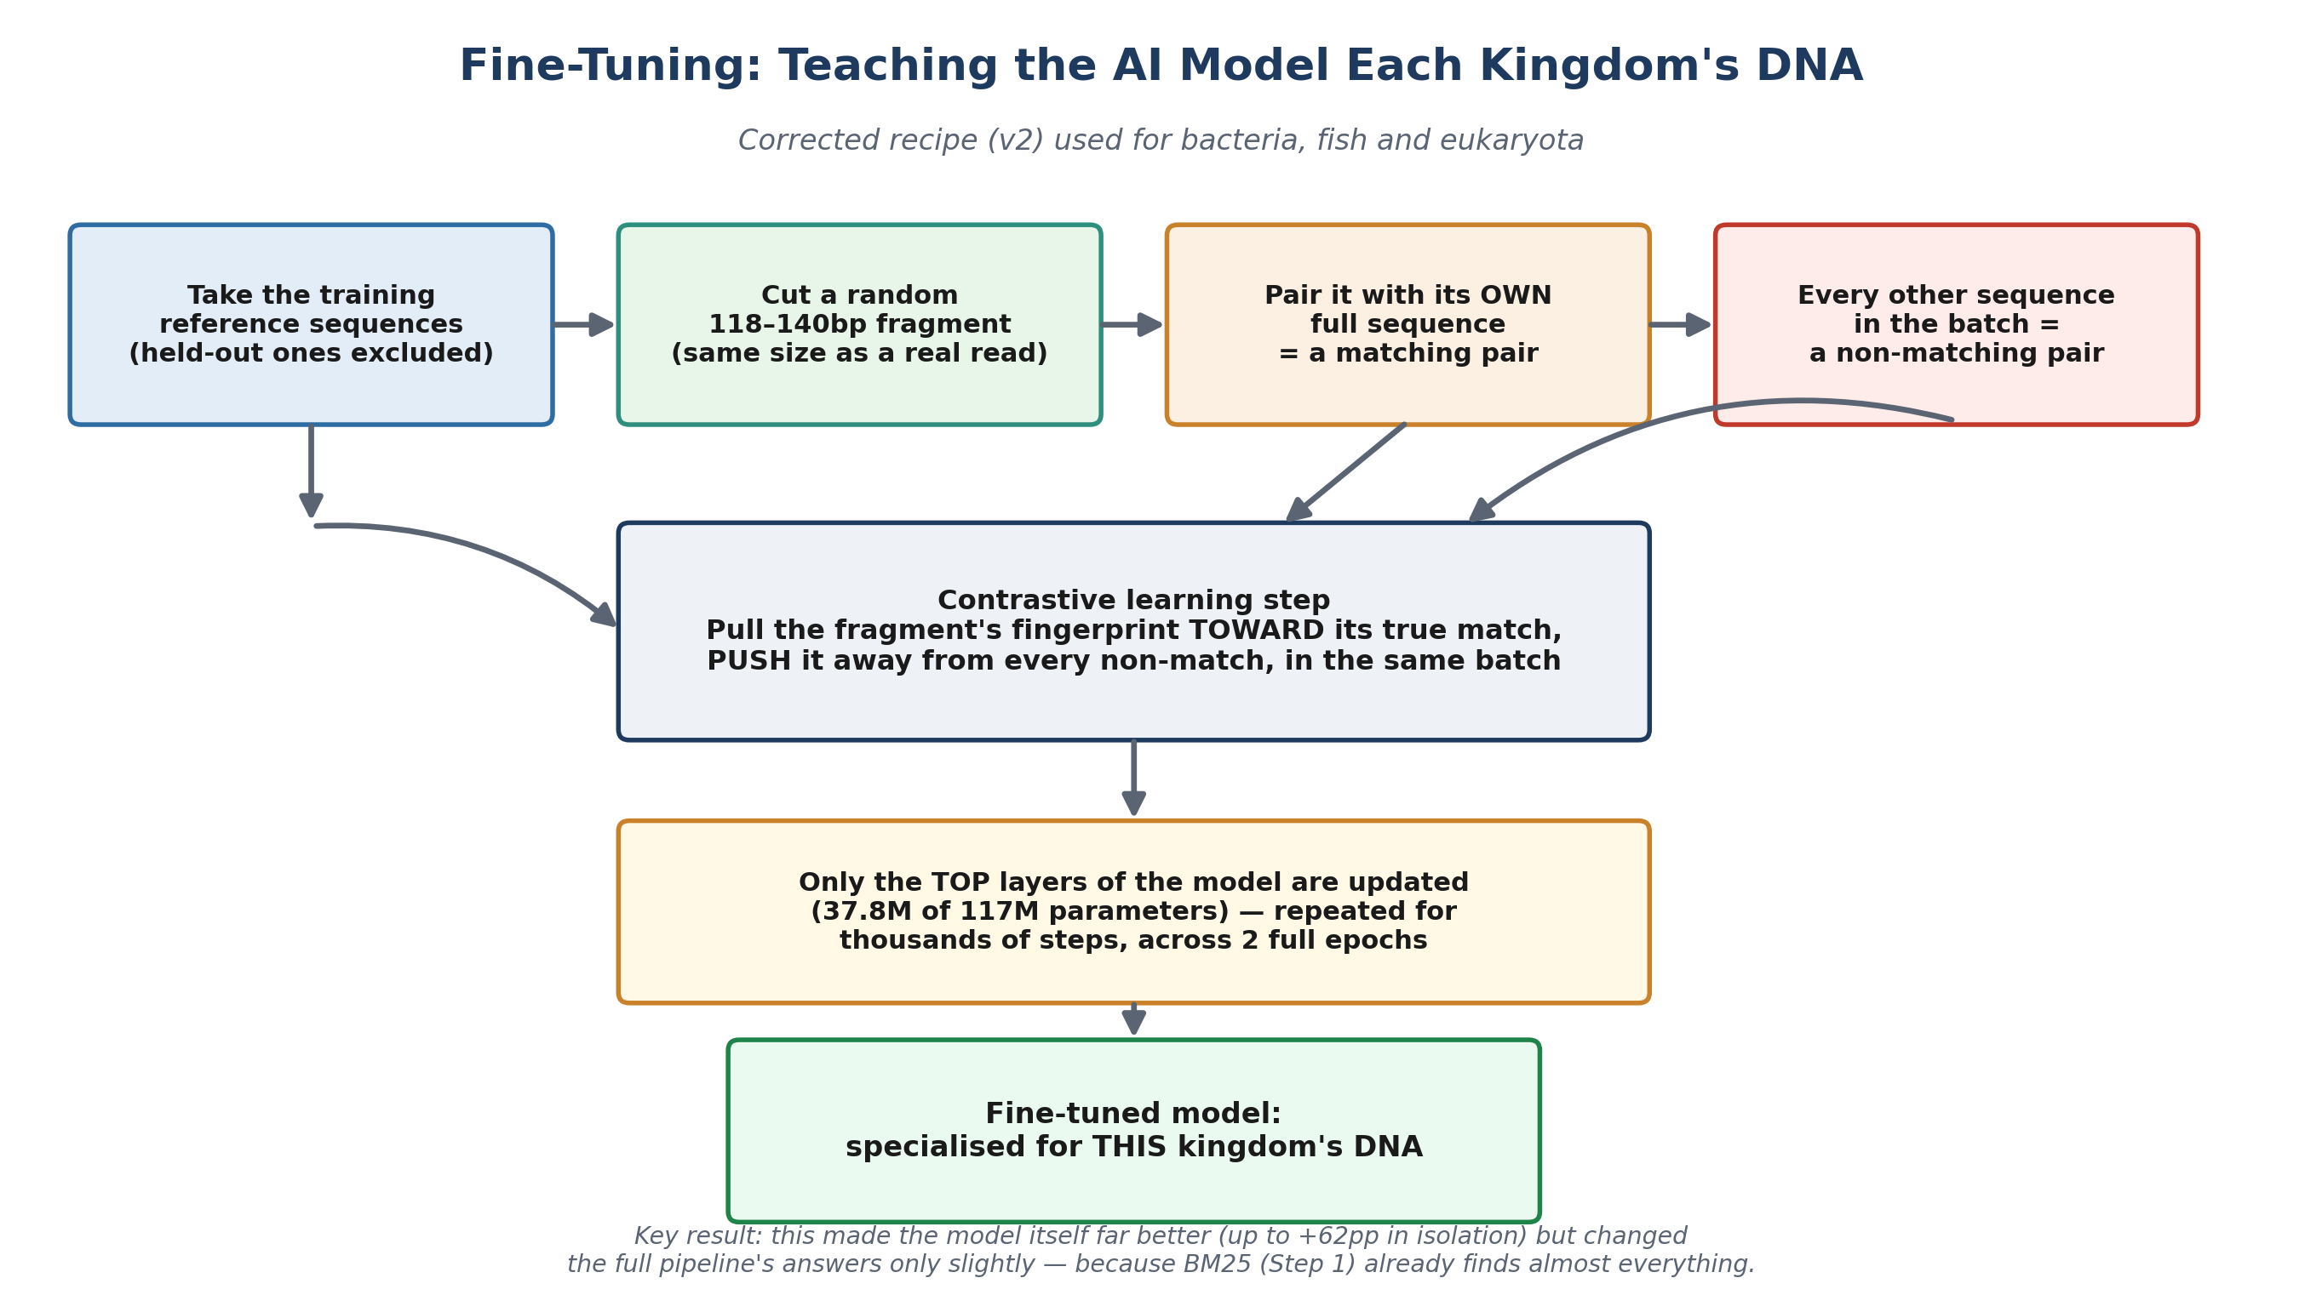
Figure 2. The corrected (v2) fine-tuning recipe used for all three kingdoms.

Step-by-step
- 1. Start from the correct data. Only sequences in the training split are used — the split is generated by a fixed, repeatable random process (“seed 42”) that holds back 20% of references for testing. This guarantees the model never sees what it will later be tested on.
- 2. Cut a realistic fragment. For every training reference, a random 118–140bp window is cut out — exactly the same length range as a real DNA read. This is the single most important fix from Part 12: the model must practise on the same kind of short fragment it will actually be asked to identify later.
- 3. Build matching and non-matching pairs. The fragment and its own full source sequence form a “positive pair” — they should end up with similar AI fingerprints. Every other sequence sharing the same training batch acts as a “negative” — it should end up with a different fingerprint.
- 4. The learning signal. Using a mathematical technique called supervised contrastive loss, the model's internal numbers are nudged so the positive pair's fingerprints move closer together and every negative pair's fingerprints move farther apart, all within the same batch of 8 sequences shown twice each (16 total “views” per step).
- 5. Update only the top layers. Rather than retraining the entire 117-million-parameter model (which risks damaging everything it already knows and is unnecessarily slow), only the top 4 transformer layers are unfrozen and updated — 37.8 million parameters, about a third of the model. This is standard practice for specialising a large pretrained model on a smaller, specific dataset.
- 6. Repeat until done. This whole cycle — cut a fragment, build pairs, nudge the model — repeats for thousands of steps, covering the entire training set twice (2 “epochs”). Each kingdom's number of steps depends only on how much training data that kingdom has: fish had by far the most data (13,274 references) and so took the longest (93 minutes); plankton had the least (683 references) and finished in 23 minutes.
- 7. Evaluate honestly, twice. A separate script measures Recall@K (does the true match appear in the model's top K guesses?) on the held-out test fragments the model never saw, comparing the fine-tuned model against the original, untouched (“frozen”) model on the identical test set. Then a second script feeds both versions through the FULL four-step production pipeline to see whether the improvement actually reaches the final answer.

Why the loss number alone cannot be trusted (a real lesson from this project)
“Loss” is a single number the training process tries to shrink every step. It went down in every single training run in this project, including the very first, broken bacteria attempt in Part 11. But Part 12 discovered that a falling loss number can be achieved by “cheating” — in that case, by making 418 different bacteria sequences look artificially identical, which technically reduces the loss while destroying the fine detail the actual task needs. The only way to know if training genuinely helped was to test it on the real, holdout task (Recall@K) — never to trust the training loss number by itself.

13. Complete Results Summary
Every fine-tuning result in the project, gathered in one place, using the corrected (v2) recipe throughout:

13.1 The AI model tested on its own (isolated Recall@10)
Kingdom | Untrained model | Fine-tuned model | Improvement | Test set size
Bacteria/Archaea | 17.1% | 79.2% | +62.1pp | 1,000 fragments
Fish | 58.2% | 93.4% | +35.2pp | 1,000 fragments
Eukaryota (plankton) | 62.9% | 69.7% | +6.7pp | 89 fragments ¹

¹ Small test set — treat this delta as indicative rather than precise; each fragment is worth about 1.1 percentage points.

13.2 The same AI model, inside the full production pipeline
Kingdom | Correct calls, untrained model | Correct calls, fine-tuned model | Change
Bacteria/Archaea | 782 / 1,000 | 784 / 1,000 | +2
Fish | 936 / 1,000 | 936 / 1,000 | 0 (identical)
Eukaryota (plankton) | 63 / 89 | 63 / 89 | 0 (identical)

The pattern across all three kingdoms is the same: a large, genuine improvement to the AI model translates into little to no improvement in the final, real-world answer, because the earlier BM25 search step already finds nearly every retrievable correct answer before the AI model gets involved.

13.3 MMR vs. RRF, final verdict per kingdom
Kingdom | MMR: Recall@1 / correct calls | RRF: Recall@1 / correct calls | Winner
Bacteria/Archaea | 78.8% / 784 | 75.2% / 791 | MMR (cost; near-tied accuracy)
Fish | 93.7% / 936 | 92.1% / 936 | MMR (higher Recall@1, tied calls)
Eukaryota | 70.8% / 63 | 68.5% / 63 | MMR (higher Recall@1, tied calls)

MMR is retained in production for all three kingdoms. It never loses on both accuracy and Recall@1 simultaneously, and unlike RRF it does not require running the AI model live for every incoming read.

14. What Is Still Open
In the interest of full honesty, here is exactly what this project has not yet answered:
- 1. Could a different architecture unlock the fine-tuning gain? Every architecture tested so far (BM25 alone, BM25→MMR, BM25+RRF) still takes BM25's initial 30-candidate shortlist as fixed. None of them can answer whether widening that shortlist, or combining BM25 and the AI model earlier in the process (rather than after BM25 has already narrowed things down), could let the fine-tuned model's large isolated improvement actually reach more final answers.
- 2. Plankton's small sample size. Plankton's entire usable reference library is only 853 records, giving a held-out test set of just 89 fragments. Every plankton number in this report should be read with that small sample size in mind.
- 3. No independent species check for plankton. SILVA's own species labels for the plankton hits say only “uncultured eukaryote” — there is no way, using this database, to independently verify those matches the way Part 4 verified fish matches against NCBI's tuna records, or the way Part 10 spot-checked bacteria genera against known marine microbiology.
- 4. Growing the plankton reference library. Only fish (Part 3–4) and bacteria (Part 10) have been tested against real, independently-sourced ocean DNA samples with any plausibility check at all. A wider, properly re-extracted plankton reference library (matching the un-truncated 1510R primer site) would be the natural next step to test whether plankton's low coverage improves with a larger comparison library, the same way MitoFish's full 16,592-record library outperformed an earlier, smaller 5,000-record SILVA sample for fish.
Nothing above contradicts the results already reported — they are simply the next, still-unanswered questions the project could pursue.

